Chapter 7, Problem 50.

In the circuit in Fig. 7.117, find i_{x} for t > 0. Let R₁ = R₂ = 1 kΩ, R₃ = 2 kΩ, and
C = 0.25 mF.

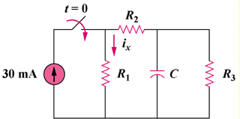

Figure 7.117
For Prob. 7.50.

